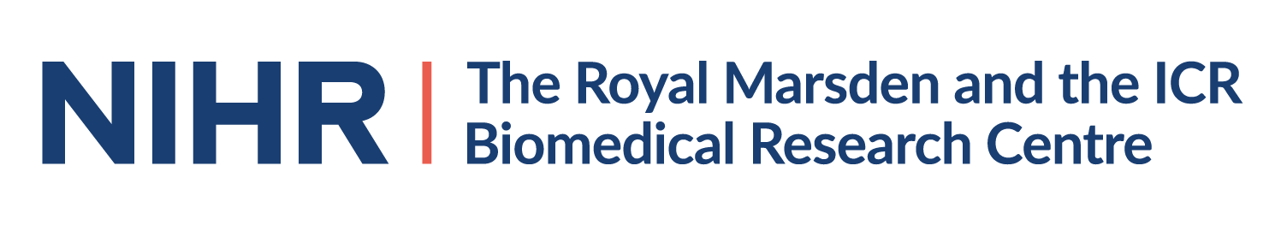
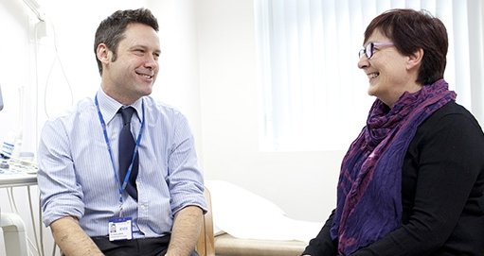
Patient, Carer, Family And Friends Event
Pioneering treatment: What does the future hold for Melanoma and Urological Cancers?
An evening of the latest clinical research innovations and what this means for cancer care and treatment
When: Tuesday 2nd July 2019
Time: 16.00– 19.45
Location: The Royal Marsden Education and Conference Centre Stewart’s Grove, London SW3 6JJ
Prof. Robert Huddart

Buffet and drinks reception available from 16:00
Join us at our open evening to:
- Meet our world-leading clinicians and researchers

- Learn about melanoma, kidney, bladder and testes cancers and your health and care
Dr Christina Messiou
- Discover new treatments and technology being developed

- Ask your questions, share your thoughts, shape future research
Did you know that The Royal Marsden, in association with The Institute of Cancer Research, is ranked in the top four centres for cancer research and treatment worldwide?
Programme
16.00 -17.00 | Registration  With drinks and buffet.  Displays from our charity partners Melanoma UK, Kidney Cancer UK, Kidney Cancer Support Network, Cancer Research UK, Macmillan Cancer Support, Fight Bladder Cancer, Action Bladder Cancer, ORCHID, the ICR Charity and The Royal Marsden Cancer Charity.
17:00 | Welcome  James Larkin
17.05 | What are Melanoma and Kidney cancers?  James Larkin
17.20 | What are Bladder and Testicular cancers?  Robert Huddart
17.30 | Advances in Radiotherapy  Shaista Hafeez
17.40 | Assessing quality of life of cancer patients  Olga Husson
17.50 | Next generation Nursing – contributing to research excellence  Kim Edmonds
18.00 | Living With and Beyond Cancer  Alison Reid
18.10 - 18.30 | Comfort Break
18.30 | Artificial Intelligence in cancer imaging  Christina Messiou
18.40 | Cancer Evolution - Explained  Samra Turajlic
18.50 | Pioneering Surgery  David Nicol
19.00 | How research changed my life  A patient’s perspective
19.10 - 19.40 | Audience Q&A- What is important for future research?  Panel to include Doctors, Nurses, Researchers and Patients.
19.40 | Closing

To attend you must register and receive confirmation. Places are limited so please register early. For more information and to register, please get in touch:
- Website: cancerbrc.org/melanoma-and-urological-cancers
- Telephone: Lisa on 0203 186 5408 or Suzan on 0203 186 5409
- Email: cancerBRC@rmh.nhs.uk

